 

**Placement Empowerment Program**

***Cloud Computing and DevOps Centre***

Set Up a Local Git Repository: Initialize a Git repository locally and version control your static website

**Name**: Yasvanth Rajan E  **Department**: AML



**Introduction**

In this POC, we will initialize a local Git repository to version control your static website. This allows you to track changes to your project files, experiment with new features in a controlled environment, and easily share your project with others when needed. Setting up a Git repository is an essential step in maintaining an organized and reliable workflow, particularly for developers and teams working on collaborative projects.

**Overview**

Here’s what we will cover in this setup:

**1. Installing Git**: Ensure Git is installed on your system and properly configured.

**2. Creating a Local Repository**: Initialize a Git repository in the root folder of your static website

**3. Staging and Committing Files**: Add your project files to the staging area and commit them to the repository to save a snapshot of your work.

**4. Reviewing the** evolves. **Repository State**: Use Git commands to check the status of your repository and verify that everything is tracked properly.

**Objectives**

By the end of this POC, you will:

**Understand the Basics of Version Control**: Learn the significance of Git in managing and tracking changes in your projects.

**Set Up a Git Repository**: Discover how to initialize a Git repository to locally version control your static website.

**Track Changes Effectively**: Master the process of staging and committing files to ensure every change is recorded.

**Organize Your Project**: Keep your static website’s workflow clean and structured, with the ability to revert changes as needed.

**Prepare for Collaboration**: Get ready to share your repository and collaborate with others using Git, when necessary.

**Importance of Setting Up a Local Git Repository**

**Track Changes**: Git logs all modifications, maintaining a clear history of your project’s evolution.

**Rollback**: Effortlessly revert to previous versions, allowing you to recover from mistakes.

**Collaboration**: Git sets up your project for teamwork, facilitating seamless integration of changes among team members.

**Step-by-Step Overview**

Step 1:

Search for "Git" in Chrome, download it, and click the "Downloads" option on the website. Click the **Windows** option on the download page and follow the installation wizard.

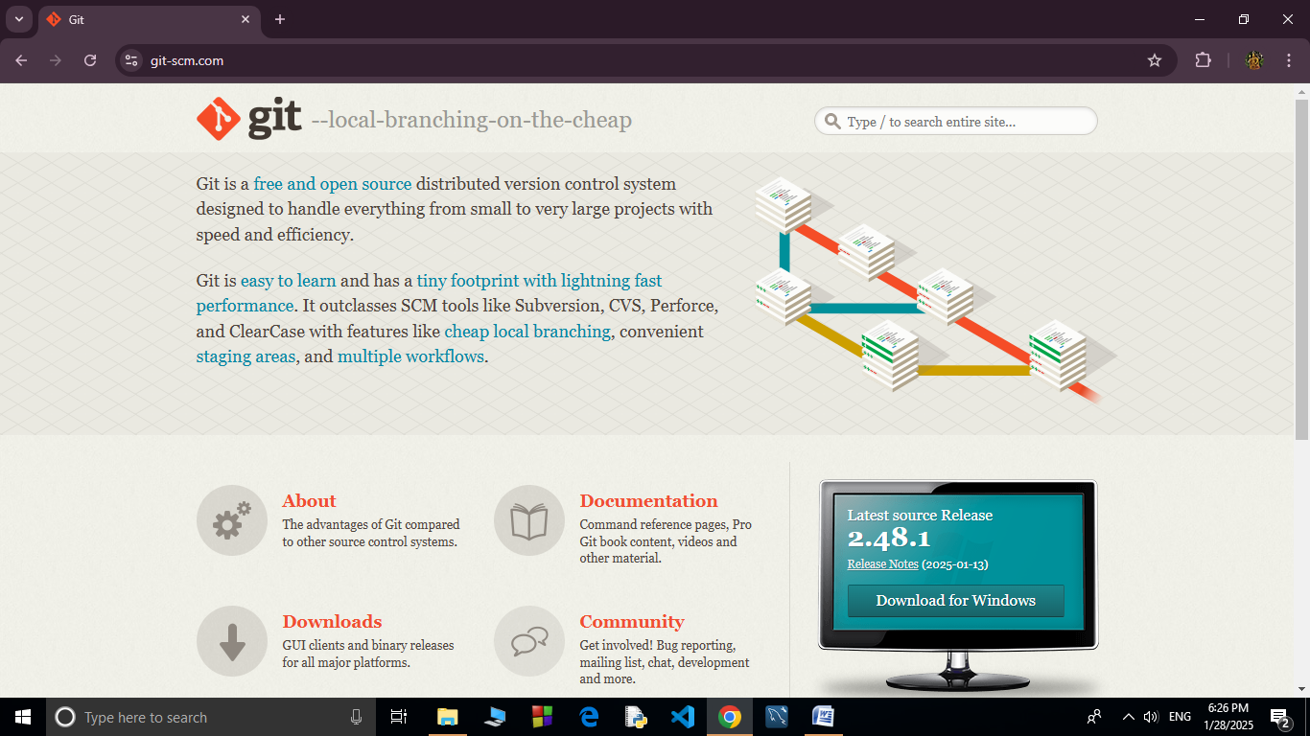

Step 2:

In your Desktop Create a folder named website for your static website

Inside that folder, create a simple HTML file named index.html. You can write some basic HTML

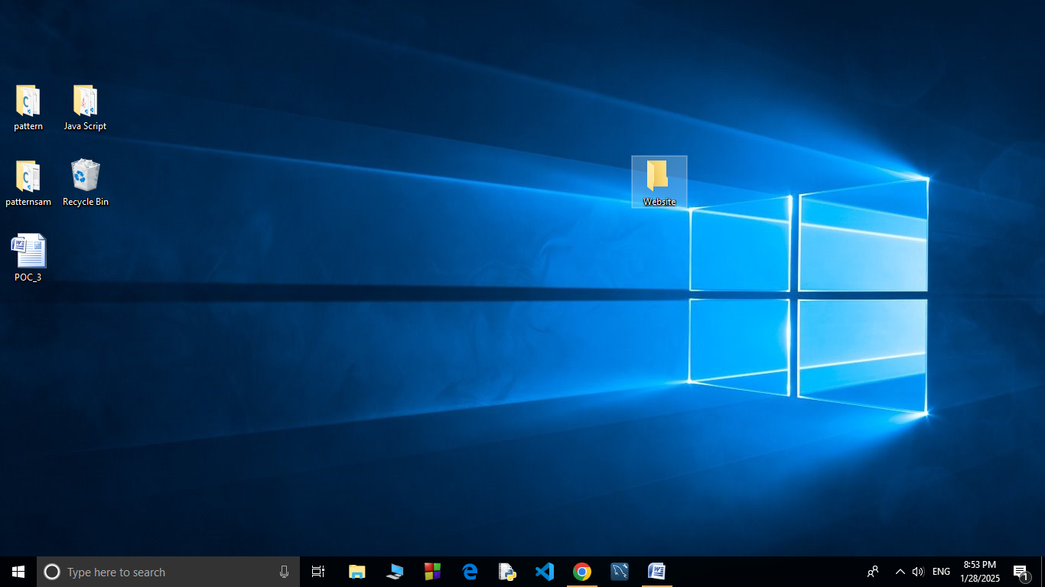

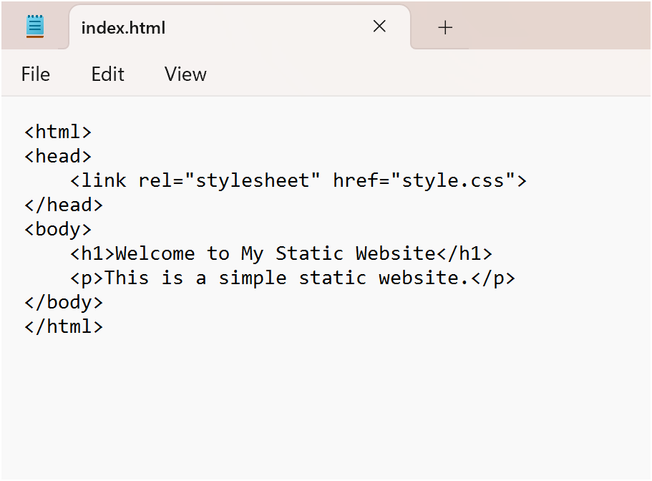

Step 3:

Open the Command prompt and set the path to the folder named website we created and Now, initialize Git by typing this command:

**git init**

This command will create a .git folder inside your project folder, which tells Git to start tracking your files.

Next, we need to tell Git to start tracking your website files.

To tell Git which files to track, use the git add command. If you want to track all the files in your folder, type

**git add .**

This command adds all the files to Git’s tracking system.

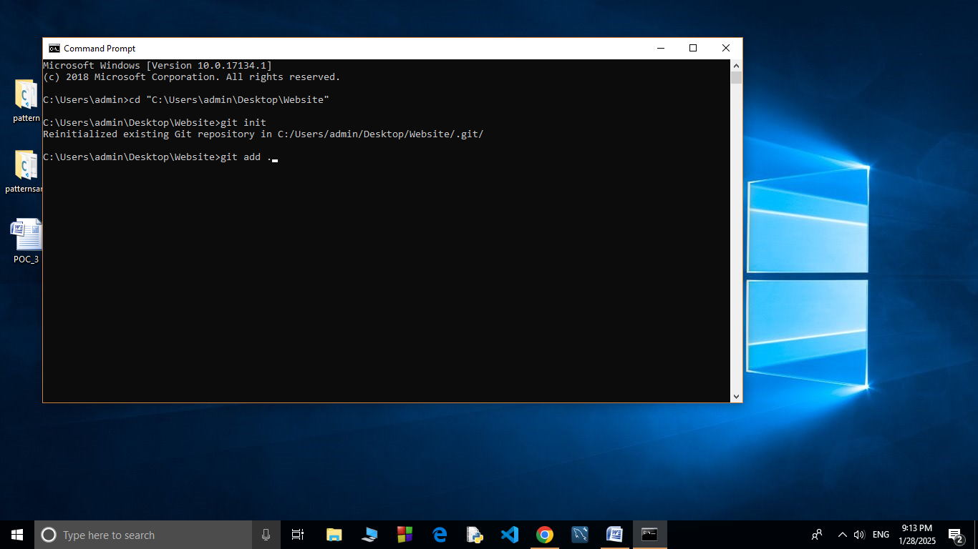

Step 4:

Set Up Your Name and Email Globally Git doesn’t know who is making the commit because you haven’t configured your name and email yet. Git uses this information to track who made the changes.

Now, we need to save these changes in Git. When you "commit" changes, Git takes a snapshot of your files.

Type the following command to commit your changes:

**git commit -m "Initial commit of my static website"**

The -m flag allows you to add a message about your changes. In this case, we’re saying this is the "initial commit," meaning the first time we’re saving our work

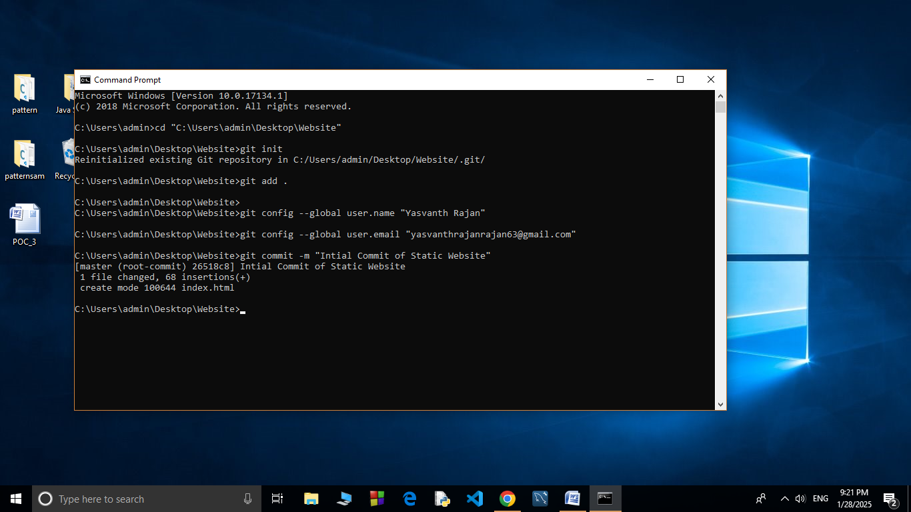

Step 5:

**Create a New Repository**:

Once you're logged in, click the green **"New"** button on the top- right of your GitHub homepage to create a new repository.

Give your repository a name, for example, my-website.

Leave the other settings as default, and click **"Create repository"**.

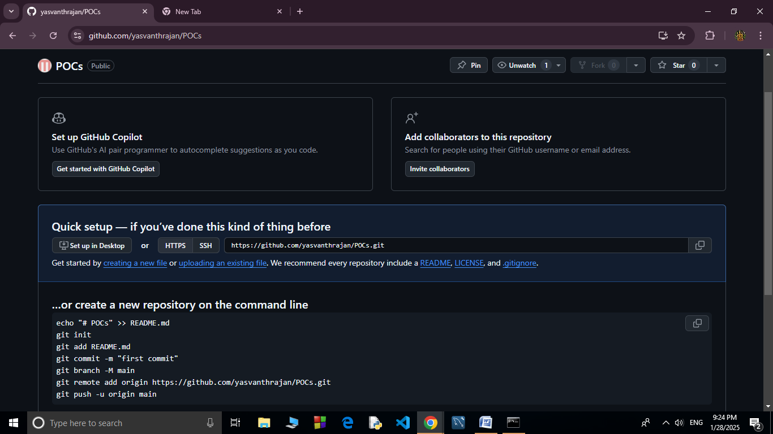

Step 6:

**Add the Remote Repository URL to Your Local Repository**:

Go back to your Command Line and type the following:

**git remote add origin https://github.com/yourusername/my-website.git**

Replace yourusername with your GitHub username and my-website with the name of your GitHub repository.

The **git branch -M** main command is used to **rename the current branch** to main. Here's what it does:

**-M**: This flag forces the renaming, even if a branch named main already exists. It will overwrite the existing main branch.

**main**: This is the new name for the current branch

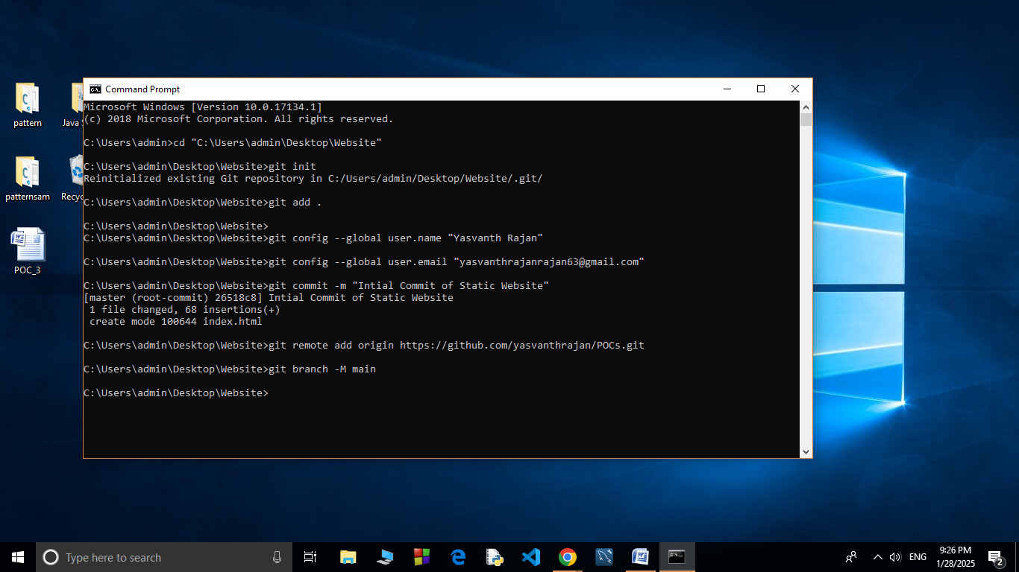

Step 7:

The command git **push -u origin main** is used to push your local **main** branch to the remote repository (**origin**) and set it as the upstream branch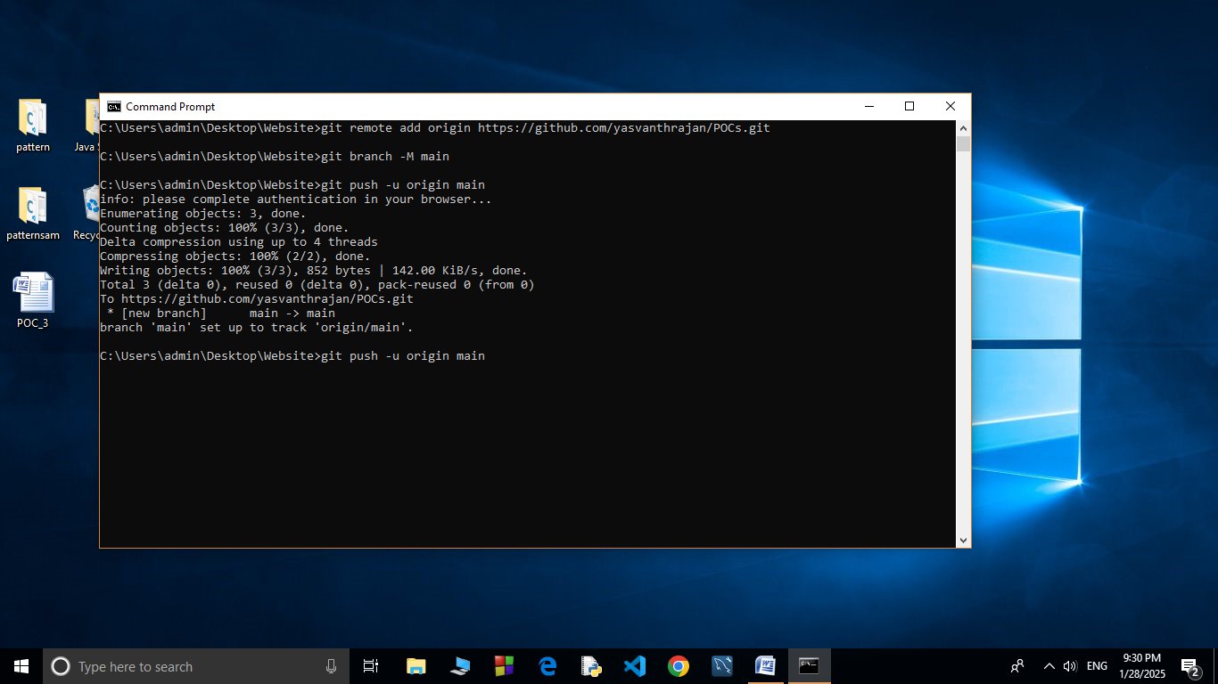

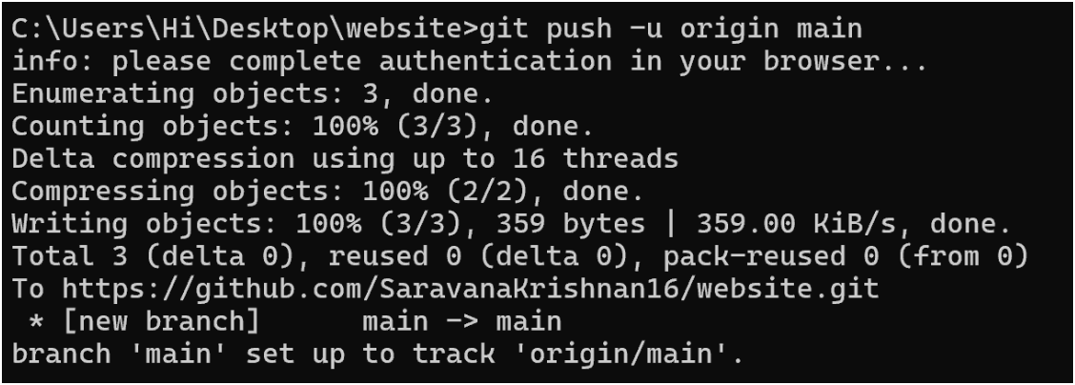

Step 8:

Verify Your Files on GitHub

Go to your GitHub Repository:

Open your web browser and navigate to your GitHub repository (e.g., https://github.com/yourusername/my-website).

You should see your website files there!

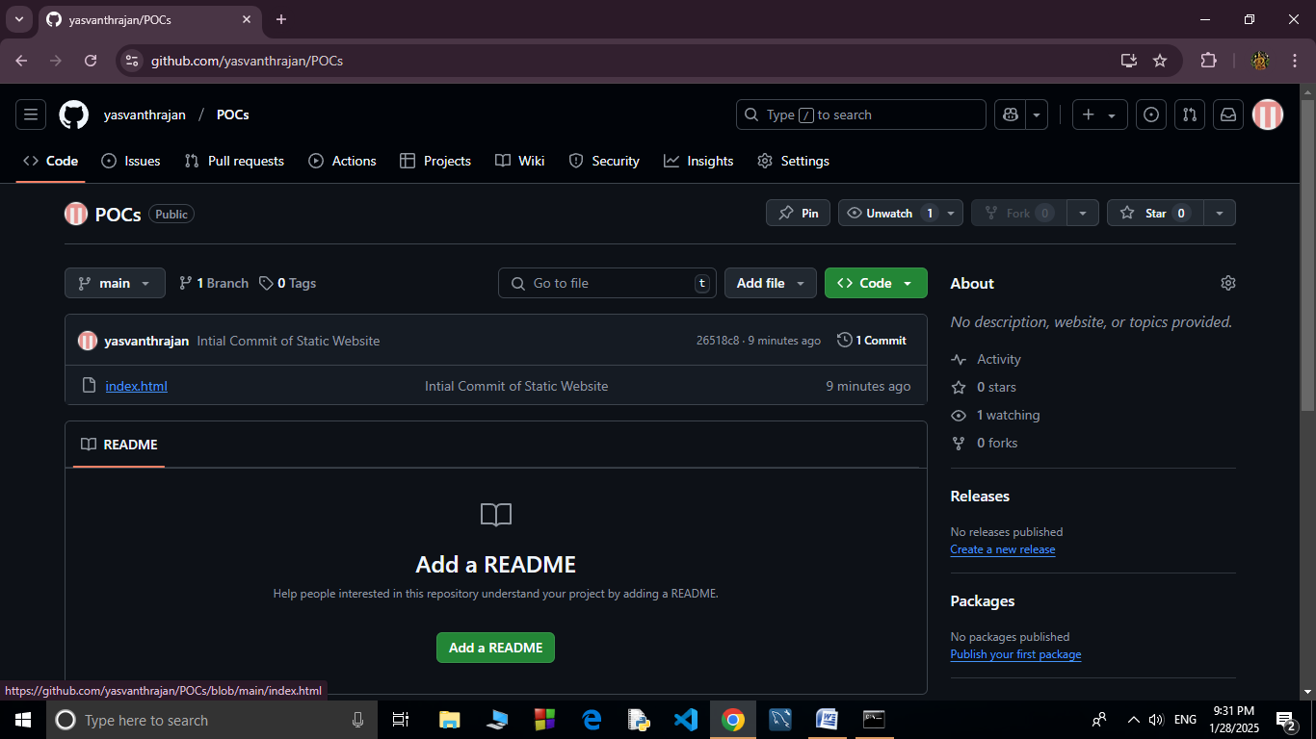

**Expected Outcome**

By completing this PoC of setting up a local Git repository, you will:

1. Successfully initialize a Git repository in your local static website folder.

2. Track changes made to your website files (HTML, CSS, etc.) using Git version control.

3. Understand the basic Git commands (git init, git add, git commit) for version control.

4. Commit your changes locally with a descriptive commit message.

5. Gain hands-on experience with Git and how it helps manage and track website file changes.